Capstone Project On Neighborhoods of Toronto

Business Problem :
Toronto has lots of stores, eateries, Coffee shops etc. The purpose is to recommend the owner the best place to open the stores/eatery. We shall try to find out the best neighborhood and store in Toronto using with Foursquare map.

Necessities/ Requirements for this:
- Foursquare developer account for API calls.
- Need Neighborhoods with Latitude and Longitude
- Knowledge of Data Analysis, Data Visualization, Data Processing and Machine learning algorithms.
- Need Data for Toronto City.

Methodology:

CRISP-DM – Cross Industry Standard Process for Data Mining

The typical steps involved in CRISP-DM comprise:

- Business Problem
- Data Understanding
- Data Preparation
- Modeling
- Evaluation
- Deployment

Data Requirements:

- We would need the Foursquare location data to solve the problem.
- We would also need Geospatial_data for Toronto location.

Required Python Libraries for this Project :
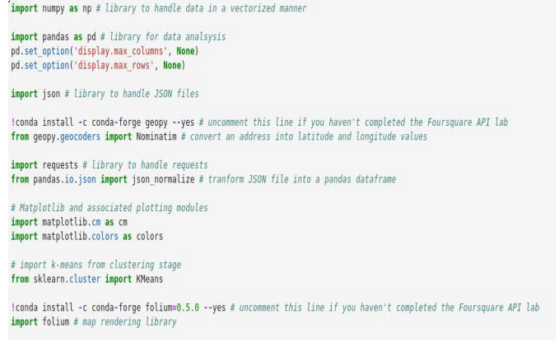

Required FourSquare Parameters : Client Id, Client Secret and Version of the URL.

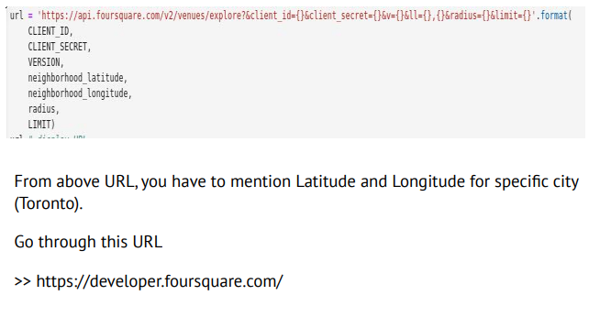

FourSquare Venues with ratings:

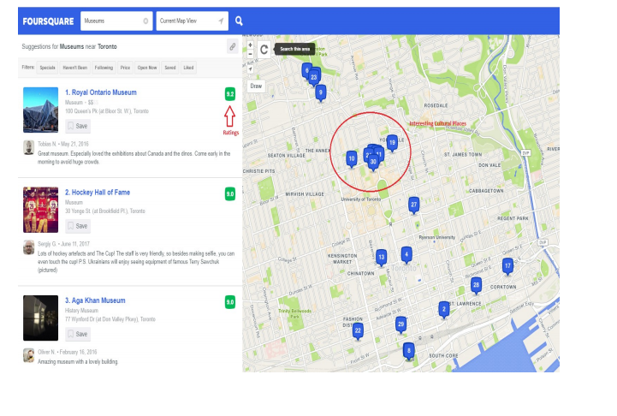
Data Understanding : Things that matter :
– Is this Data sufficient ?
– What are the parameters required ?
– Is the problem Supervised or Unsupervised (Depending on the problem statement)
– Type of data we are dealing with i.e.,Text, Table format, Image, audio or Video
– What libraries are required for this project ?

Data PreProcessing :
Acquire the data using Pandas;
>> import pandas as pd
>> pd.read_csv(“path”)
We can read the different formats of data like .CSV, .xls, .html, .text etc.
Clean the data :
* Missing values
* Wrong data
* Duplicate values
* Normalize the data
* Data Conversion

Data Modeling : This Project is belongs to unsupervised mechanism. In this project we used K- Means clustering algorithm.

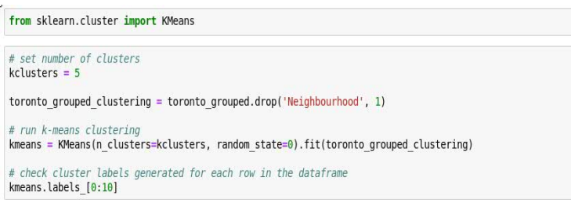

Data Evaluation : We have different types of Evaluation models
- Train_test_split
- Crossvalidation_Score
- Metrics (Accuracy Score)
Example:
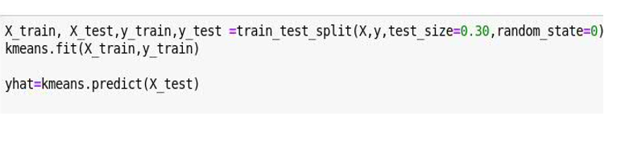

Discussion:
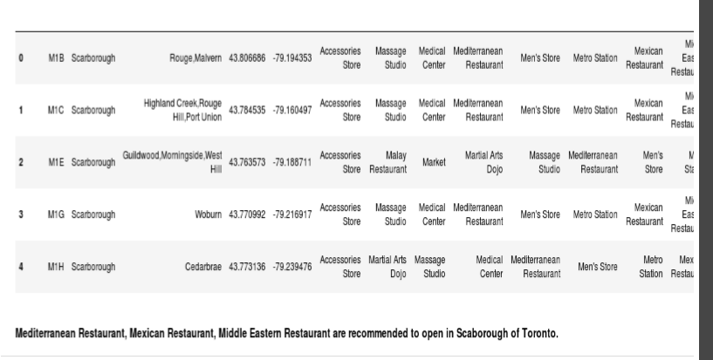

Conclusion :

- The analysis of this data is rather limited because we used only Foursquare. The ranking positions users’ ratings.
- The Clustering function can be changed and will yield different clusters. We assumed 5, but stakeholders can change this at will.
- Given the time allowed and the limited data, this was an interesting project that could very well benefit the Tourism agencies of Toronto!

